AI Chat Assistant Update:
- The AI data is updated every other day. So, the information will be delayed for 1 day, but it’s automatically updated during midnight for both Design and Sales.
- The ai can now make a single query for project details, getting all the status of project, for example, listing all the projects that are pending.
- The ai now can provide basic information according to Acumatica and BMS questions like how to file a project in BMS, how to create or file reimbursement, etc.
- So far, the AI is working and can be used but expect some bugs and errors for further updates and fixes.
- The AI is now filtered, for example, the sales can only access the sales and general information.
- The executives now can query all the data including the design, sales and general information
- Here’s the list of all the general information inserted to AI data:
  - How to file or create a Project
  - How to file or create Cash Advance in Acumatica
  - How to file or create a Project Order
  - What is the link for the EForm
  - What is the link for the Acumatica
  - How to file or create Reimbursement for Ms. Jully in Acumatica
  - How to file or create Reimbursement for Ms. Fatima in Acumatica

This is how the AI data update:
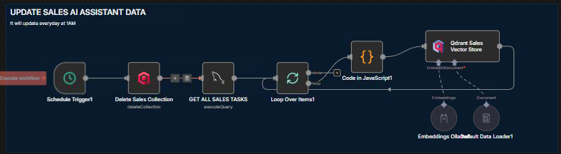
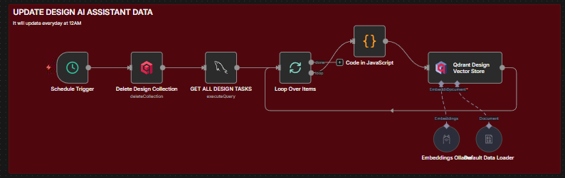
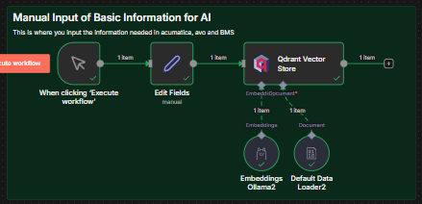

And this is how AI filtered:
